Project 10.4.3 Basic Device Configuration

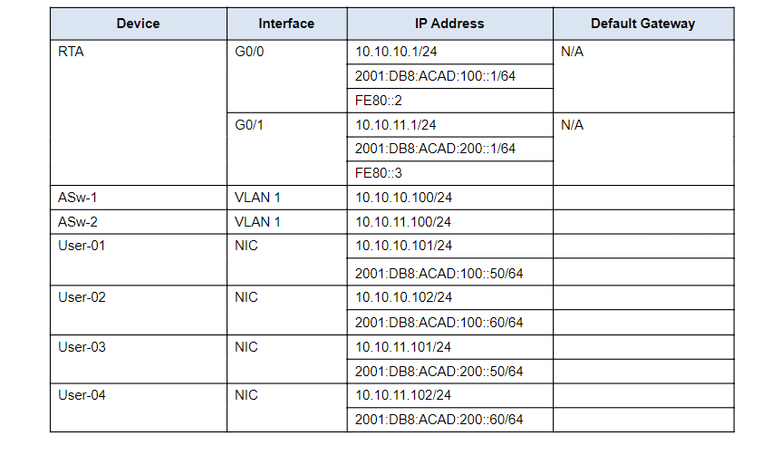

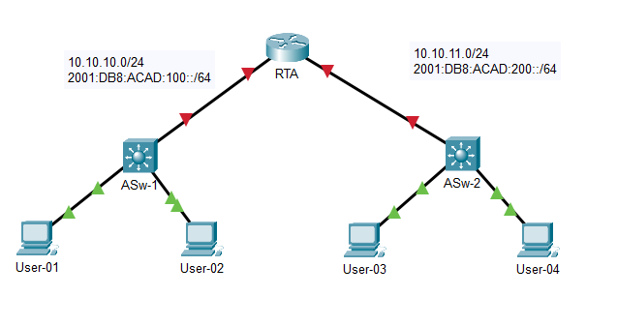

Default Gateway:

ASw-1: G0/0 10.10.10.1/24

ASw-2: G0/1 10.10.11.1/24

User-01: 10.10.10.1/24,FE80::2

User-02: 10.10.10.1/24, FE80::2

User-03: 10.10.11.1/24, FE80::3

User-04: 10.10.11.1/24, FE80::3

1. Name the router Floor14 and the second switch Room-146. You will not be able to access the Room-145 switch.

Router

En

Conf t

Hostname RTA

switch

En

Conf t

Hostname ASw-2

2. Use cisco as the user EXEC password for all lines.

Router

En

Conf t

Line console 0

Password cisco

Login

Line vty 0 15

Password cisco

Login

Switch

En

Conf t

Line console 0

Password cisco

Login

Line vty 0 15

Password cisco

login

4. Use class as the encrypted privileged EXEC password.

Router

EN

CONF T

Enable secret class

Switch

EN

CONF T

Enable secret class

5.  Encrypt all plaintext passwords.

Router

En

Conf t

service password-encryption

Switch

En

Conf t

service password-encryption

1. Configure an appropriate banner.

Router, switch

En

Conf t

banner motd #Unauthorized#

7.  Configure IPv4 and IPv6 addressing for the Floor14 switch according to the Addressing Table.

Router

En

Conf t

Int g0/0

ip address 10.10.10.1 255.255.255.0

no sh

ipv6 address 2001:DB8:ACAD:100::1/64

ipv6 address FE80::2 link-local

Int g0/1

ip address 10.10.11.1 255.255.255.0

no sh

ipv6 address 2001:DB8:ACAD:200::1/64

ipv6 address FE80::3 link-local

ipv6 unicast-routing

8.Configure IPv4 and IPv6 addressing for the switch according to the Addressing Table.

Switch

En

Conf t

Int vlan 1

Ip address 172.14.10.35 255.255.255.0

No sh

1. ·Document interfaces with descriptions, including the Room-146 VLAN 1 interface.

router

En

Conf t

int g0/0

description link to ASw-1

int g0/1

description link to ASw-2

Switch

En

Conf t

int vlan 1

description vlan1